# Project Design Document

**Project: Messaging app development**

**Author: Gede Tomi Adi Wirnaya**

**Student Number: s320346**

**Unit Code: HIT238**

**Created date: 1/9/2021**

**Last edited date**: **1/9/2021**

## Problem Statement

In the 21st century, technology has made its way through people’s life. For example, instant messaging is one of the most used technology in people’s life. No matter if they are men or women or young or old most people would be able to operate or know how to use an instant messaging service. It is free yet it is built according to the principle of “Form Follows Function”. Although to some user some of these instant messaging services are easy to use, some people find them hard to use. Some of the problem that these apps may be hard to use or contains an in-app purchase. Henceforth, what I would like to make is an instant messaging application that is easy to use yet offers the full feature to the user.

## Audience

### User Research

#### Research Plan

My research plan in this project is to interview some people or relatives and ask them to try the application. After a certain period of time, I will conduct a survey and draw a conclusion about the application.

##### Questions (objectives)

The most essential purpose of this application is to provide a free instant messaging service that is user friendly and mobile compatible as well. The main keys of the product are simplicity, security and mobile-friendly. These features are some of the instant messaging applications forgot or ignore to offer to the user.

##### Hypothesis

As per today, instant messaging is one of the important communication methods in people’s life. Some of the drawbacks on the social media offered in the market including lack of simplicity, user-friendly and mobile-friendly

##### Methods

Based on the interview conducted, the results vary from person to person. But many of the people that has problem operating the instant messaging application are from the people aged more than 50. This application is intended for those who are not tech-savvy and for those who use mobile phone quiet often.

##### Results (synthesis)

After finishing up the research that I conducted, I have compared the report and drawn the conclusion that there are more than 90% used instant messaging application in their daily life. Many of the usage are for communicating with friends, family or co-worker. Some of them also used the application for formal communication such as business or conducting a meeting. Moreover, people aged more than 50 have problem to operate most of the instant messaging app. For example, a woman aged 65 has a problem to send the message and navigating through the application. For this problem, what is needed is an easier user interface.

#### Notes

After conducting the interview and survey, I concluded that this application will be useful for people especially the elder one.

### Personas

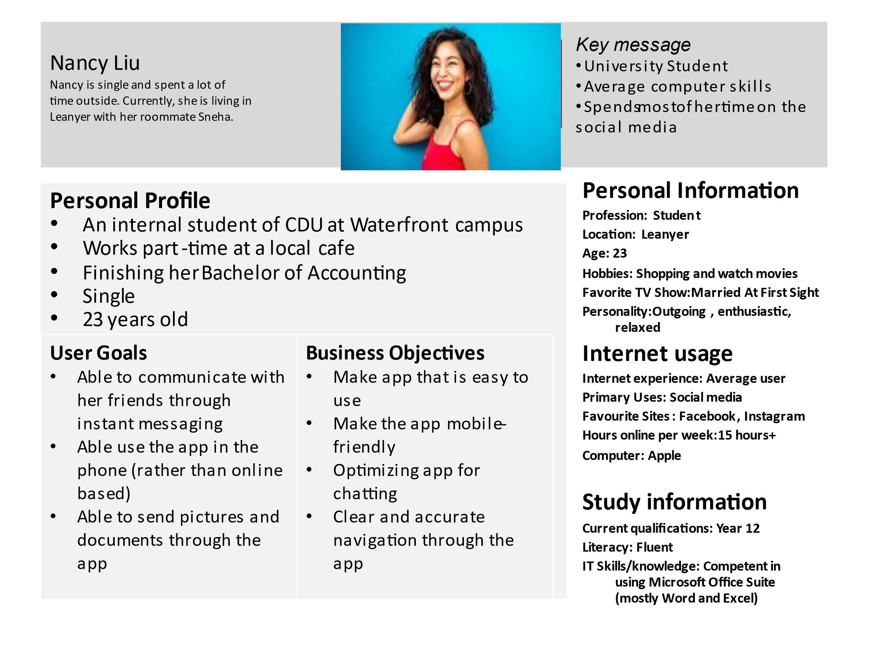

* Mobile friendly chat apps.
* User friendly include send some chat, image, video and file transfer.
* Enjoyable content.
* Optimize the group chat features.
* Stabil chat performance platform.

Age 32.

Art and family is his favourite words.

Give community chance to involved in his project.

Hire remote team member to complete task.

Has finish his visual art design degree since 2018.

USER GOALS

In order to communication with his team, he needs reliable communication app which simple, user friendly and have quick and private access to his team member.

PERSONA

Alexander Yaw, 28

Alexander is freelancer for design graphic.

PERSONAL PROFILE

Business Objective



## MVP and UX Prototype

#### User Stories

Link to Trello for description each card: https://trello.com/b/J4wpCtjt/user-stories

#### MVP Documentation

The chat app are most useful apps to send message online. It really easy and fast in term of sending and receiving message. The main feature of this app would be developing an essential group chat that allowed user to communicate with many other users by creating their own group chat massage. It also will be really useful feature to connect family group, team communication and other large scale communication among user. Following bellow is the UX flowchart by using this chat apps.

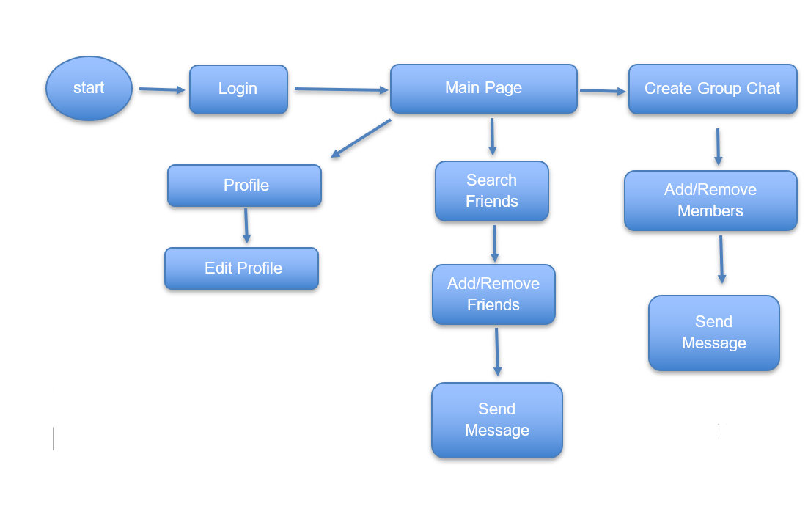

#### Diagram, schematic Description automatically generatedPaper Prototype

### 

## User Testing

The user testing have been conduct by questing a few simple question about the protype of this app and explain of how the app work to the audience. The question lists and notes are taken directly so the feedback would be written fully in word document. Questionnaire are following:

|  |  |
| --- | --- |
| Question | Answer |
| How often you using message chat ? | I use it every day, simply for sending message to anyone. |
| Do you think chat app really useful for yourself ? | Yes, like I said been using it every day. It fast and easy. |
| I am trying to develop new chat app, called iChat. It basically focusing on simple way to deliver message and file. Could you please have a look to my prototype ? | Yes, sure. |
| Did you find any difficulty from the prototype while using the app ? | No, it’s quite simple chat app. It runs like how chat app normally does. It contain your profile, searching for user so you can add or remove and create a group chat. |
| Do you like the features that have in my chat app ? | The feature is enough to cover all the message activities. Perhaps you need to add some more feature such as calls so it can be complete communication apps ? |
| At the moment, still trying and learning to develop chat app only. However for future development the call feature can be implemented. Really appreciate your feedback. | No worries, you can do it. |
| What do you think about the prototype design ? | The design is really great, its simple and straight forward. Seems I am interested to use your app. |
| Thank you so much. Last question, what improvement would you like to add for the app ? | Well, beside the one I mention before, the calls features, none its easy and simple to use for sending message. |

## Prototype

**Link:**

**Git Repository:**